|  |  |
| --- | --- |
|  | Department of Description Technology, Malang State Polytechnic  **Jobsheet-7: PHP - Form Proccessing**  **Web Design and Programming Courses**  Tutor: Web Design and Programming Teaching Team  *October 2023* |

**NAMA : SHABRINA QOTTRUNNADA**

**KELAS : SIB-2G**

**NIM : 2341760160**

**MATKUL : PRAKTIKUM PEMROGRAMAN WEB (PHP-Form Proccessing)**

**GITHUB :** [**https://github.com/shabrinaq/dasarweb_nada**](https://github.com/shabrinaq/dasarweb_nada)

**Topic**

* The Concept of Form Proccessing with PHP and Jquery

**Purpose**

Students are expected to:

1. Students are able to create forms using PHP
2. Students are able to create forms using jQuery

**Attention**

This jobsheet must be done step-by-step according to the Practical Section steps that have been given. Questions can be answered directly in the column provided using the PDF Editor.

**Introduction**

**Function isset**

**isset()** is a function in PHP that is used to check whether a variable has been defined (exists) or not. This function returns **true** if the variable has been defined and has a value, and false if the variable does not exist or has a null value. Here's an example script and a minimal explanation of isset()**:**

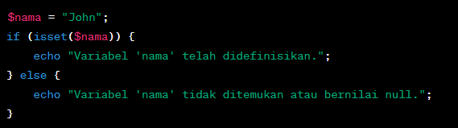

The above code checks if $nama variable has been defined. If yes, then the message "Variable 'name' has been defined." will be displayed, if not, then the message "Variable 'name' not found or null value." will be displayed.

**Practical Section 1. Function isset()**

|  |  |
| --- | --- |
| **Step** | **Description** |
| 1 | Create a new folder JS07_PHP-jQuery in dasarWeb and name it isset.php |
| 2 | Type into the isset.php file the code below. |
| 3 |  |
| 4 | Save the file, then open a browser and run localhost/dasarWeb/JS07_PHP-jQuery/isset.php. What do you understand from using the isset on the file. Give me your answer.  (Question No 1.1)  My Answer :      What I know about the isset experiment is that it is used to check that a variable that we write “$age” has been declared correctly by checking whether the age value is greater than 18 or the same. Based on this experiment the age has no value, so when it is run the output is “You are not an adult or the variable ‘age’ is not found”. If, for example, age had a value, the output would be “You are an adult”. |
| 5 | Add the contents of the isset.php file with the code below. |
| 6 | Save the file, then open the browser and run localhost/dasarWeb/JS07_PHP-jQuery/isset.php. Ensure that the output does not appear in a single line; the result from the echo should be displayed separately. Explain what you understand from the use of isset() in that file. Write your understanding below. (Question No 1.2)  My Answer :      After modifying it so that it does not become one line    In this experiment, the isset() function is used to check that the variables in the array elements, $age and $data, have been declared correctly and are not null, so that the variables will appear at run time and of course to avoid output errors. |

**Function** empty()

The empty() function in PHP is used to check whether a variable is empty or undefined. This function returns true if the variable is empty or undefined, and false if the variable has a value or has been defined. Here is an explanation and example of using empty()**:**

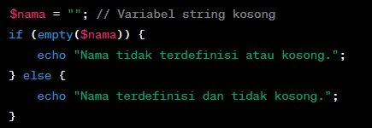

The empty() function can be used to check whether a string is empty or not.

**Practical Section 2. Function** empty()

|  |  |
| --- | --- |
| **Step** | **Description** |
| 1 | Create a new file named empty.php inside JS07_PHP-jQuery folder. Write this code into empty.php file |
| 2 |  |
| 3 | Save the file, then open a browser and run localhost/dasarWeb/JS07_PHP-jQuery/empty.php  What do you understand from the use of empty on the file. Write your understanding below. (Question No 2.1)  My Answewr :      What I understand from this experiment is that the empty class in the programming experiment is to check whether a variable is empty or not (empty because there is no variable value so that when it is run the output comes out “Array is undefined or empty”) with the empty array initialization code “$myArray = array();”. |
| 4 | Add the contents of the empty.php file with the code below |
| 5 | Save the file, then open the browser and run localhost/dasarWeb/JS07_PHP-jQuery/empty.php. Ensure that the output does not appear in a single line; the result from the echo should be displayed separately. Explain what you understand from the use of empty() in that file. Write your understanding below. (Question No 2.2)  My Answer :      After I modify it so that the variable when it appears is not just one line    In this experiment, the empty() function is to check for an empty variable or array (no variable value). “$myArray = array();” is used to initialize the empty array and will be called at ‘if (empty($myArray)) {’, so the output displayed is ‘The array is undefined or empty’, but if there is a variable value then the output will appear ‘The array is defined and not empty’.  For the code on line 8, it is to check for undeclared variables and will be called on “if (empty($nonExistentVar)) {” so that the output displayed “Variable is undefined or empty”, but if the variable has been declared, the output will appear “Variable is defined and not empty”. |

**Practical Section Part 3: PHP Input Form**

|  |  |
| --- | --- |
| **Step** | **Description** |
| 1 | Create a new file named form.php inside JS07_PHP-jQuery folder. Write this code below |
| 2 | My Answer : |
| 3 | Create a new file named form_process.php inside JS07_PHP-jQuery folder Type the code in step 2 inside the form_process.php |
| 4 | Save the file, then open a browser and run localhost/dasarWeb/JS07_PHP-jQuery/form_process.php. What do you understand from the use of forms in the file. Write your understanding below. (Question No. 3.1)  My Answer :      In this experiment, what I understand about the program code is that it is designed to receive input from the user via the POST method, indicated by the code “if ($_SERVER[”REQUEST_METHOD“] == ‘POST’) {”, to check whether the received request is the result of a form submission. If the data entered is valid and submitted through the form, the information will be stored in the $name and $email variables using the $_POST superglobal. After that, the program displays these values using the echo command. |
| 5 | Create a new file named form_self.php inside JS07_PHP-jQuery folder Type the code below inside form_self.php |
| 6 | Save the file, then open a browser and run localhost/dasarWeb/JS07_PHP-jQuery/ form_self.php. What do you understand from the use of forms in the file. Write your understanding below. (Question No 3.2)  My Answer :      In this experiment, what I understand from this experiment is that we are taught to create a php input form with hmtl and php code, which is used to ensure that the user does not leave the field empty before submitting the form. If it is not empty then the user can submit the form and the results will appear and be successfully saved. |

**HTML Injection**

HTML injection (also known as an "HTML injection attack" or "client-side injection") is a security attack that occurs when an attacker injects malicious HTML or JavaScript code into the input received by a web application. The malicious code will be executed by the user's browser viewing the affected web page, which could result in illegal access to data, changes in page view, or other attacks.

An attacker can try to inject malicious HTML or JavaScript code into the input received by the web application. If the web application does not properly sanitize or escape input, then the malicious code will be executed by the user's browser, which can cause security issues.

**Example HTML Injection:**

For example, we have a simple search form on a website that searches for keywords among user reviews:

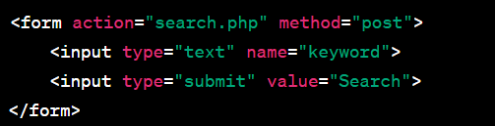

Now, if a web application doesn't validate the input correctly, an attacker can enter malicious input like this:



If the web application does not avoid or clean up this input before displaying it on the search results page, then the result will look like this:



The malicious JavaScript code will be executed by the user's browser and will bring up a "You have been hacked!" warning box. This is a simple example of HTML injection. As a web developer, it is important to always sanitize and validate input from users, as well as avoid displaying user input directly on web pages without proper escaping or sanitation to avoid these kinds of attacks.

**How to Handle HTML Injection**

The way to handle HTML injection is to validate, filter, and avoid displaying user input without proper escaping. Here are some steps to protect your app from HTML injection:

1. **Input Validation**: Validate input from users to ensure that only valid data is received. You can use functions such as filter_input() or filter_var() to perform validation.
2. **Filter Input**: Filter user input to remove or replace potentially harmful characters, such as **<**, **>**, **&**, and more. You can use functions like htmlspecialchars() or strip_tags() for this.
3. **Parameterized Statements (Query):** If you generate SQL queries with user input, use parameterized statements or prepared statements to prevent SQL injection, which can be a form of attack similar to HTML injection.
4. **Content Security Policy (CSP):** Apply a Content Security Policy (CSP) to your HTTP headers to control the resources that can be used within your web pages.
5. **Escape Output**: When you display data on a web page, make sure you avoid JavaScript injection by using htmlspecialchars() or similar methods.

Here's a simple example in PHP to solve HTML injection:

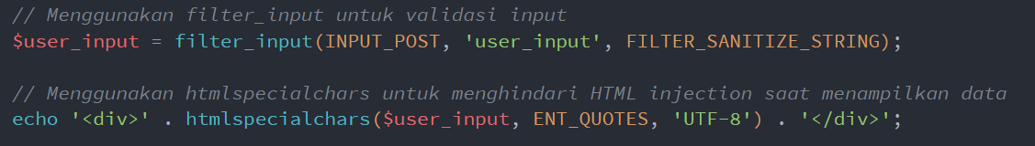

By using these steps, you can mitigate the risk of HTML injection in your web application. It's always important to validate inputs, clean incoming data, and avoid displaying user data without proper escaping.

**Practical Section 4 : HTML Injection**

Practical Section Steps:

|  |  |
| --- | --- |
| **Step** | **Description** |
| 1 | Create a new file named html_safe.php inside JS07_PHP-jQuery folder. Type the code below inside html_safe.php |
| 2 |  |
| 3 | Add another script so that step 2 can run normally, save the file. Then open a browser and run localhost/dasarWeb/JS07_PHP-jQuery/html_safe.php |
| 4 | Note here what you observe from the addition of the program code above. (Question No. 4.1)  My Answer : |
| 5 | Type the additional code in step 6 inside the html_safe.php |
| 6 |  |
| 7 | Complete the program code above so that the result is neat. Save the file, then open a browser and run /refresh localhost/dasarWeb/JS07_PHP-jQuery/html_safe.php |
| 8 | Note here what you observe from the addition of the program code above. (Question No. 4.2)  My Answer : |

**Regular Expression (Regex)**

Regex is a powerful tool for searching, matching, or manipulating text based on specific patterns. You can use it for various purposes such as input validation, text search, text replacement, and more.

**Basic Regex Patterns:**

* **Single Character**: Any character will match itself in Regex, except for special characters that must be avoided with escape characters.
  + Example: The **/a/** pattern will match the letter "a" in the text.
* **Specific Characters**: You can match specific characters by mentioning them in a pattern.
  + Example: **The /hello/** pattern will match the text "hello" in the text.
* **Special Characters**: Some special characters in Regex should be avoided with escape characters (**\**) if you want to match them literally. Examples of special characters: ., *, +, ?, |, [, ], (, ) , {, }, ^, $, \.
* **Character Set**: You can match characters from a set of characters by using [ ]. For example, /[aeiou]/ will match one of the vowels.
* **Character Range**: You can use **-** in a character set to specify a character range. For example, /[a-z]/ will match any lowercase letters.
* **Quantifier**: You can set the number of times a character or group of characters should appear beforehand. Example quantifier:
  + *: 0 or more
  + +: 1 or more
  + ?: 0 or 1 time
  + {n}: Exactly n times
  + {n,}: At least n times
  + {n,m}: At least n times, maximum m times

**Examples of Regex Usage:**

1. Matching patterns

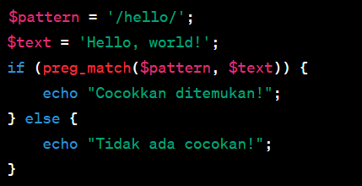

1. Match set characters

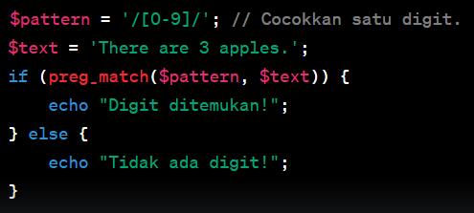

**Practical Section 5 : The Use of Regex in PHP**

Practical Section Steps:

|  |  |
| --- | --- |
| **Step** | **Description** |
| 1 | Create a new file named regex.php inside JS07_PHP-jQuery folder Type the code in step 2 inside the regex.php |
| 2 |  |
| 3 | Save the file, then open a browser and run /refresh localhost/dasarWeb/JS07_PHP-jQuery/ regex.php |
| 4 | Note here what you observe from the addition of the program code above. (Question No 5.1)  My Answer :      In this experiment in the regex.php file, $pattorn is used to store pattorn(pattern), and if the output is “Lowercase letters found!” when run then the variable in $text has been stored and we have defined $pattorn in the appropriate pattern. |
| 5 | Type the additional code in step 6 inside the regex.php |
| 6 |  |
| 7 | Complete the program code above so that the result is neat. Save the file, then open a browser and run /refresh localhost/dasarWeb/JS07_PHP-jQuery/regex.php |
| 8 | Note here what you observe from the addition of the program code above. (Question No. 5.2)  My Answer :      in this step, it is used to match the number that will be stored in the $pattorn variable, and the String will be stored in $text. While preg_match() is used to check whether the pattern that has been defined is contained in the string. If the pattern is found, the result will be stored in the $matches array, and the displayed output will show the matched number, which is “Match: 123”. |
| 9 | Type the additional code in step 10 inside the regex.php |
| 10 |  |
| 11 | Complete the program code above so that the result is neat. Save the file, then open a browser and run /refresh localhost/dasarWeb/JS07_PHP-jQuery/regex.php |
| 12 | Note here what you observe from the addition of the program code above. (Question No 5.3)  My Answer :      In this step, we will change apple to banana in the output, the variable $pattern is defined to match the word “apple”. Then, using the preg_replace() function, the code replaces all occurrences of the word “apple” in the $text string containing “I like apple pie.” with the word “banana”. As a result, the variable $new_text will store the value “I like banana pie.” and then be printed using echo $new_text;. |
| 13 | Type the additional code in step 14 inside the regex.php |
| 14 |  |
| 15 | Complete the program code above so that the result is neat. Save the file, then open a browser and run /refresh localhost/dasarWeb/JS07_PHP-jQuery/regex.php |
| 16 | Note here what you observe from the addition of the program code above. (Question No 5.4)  My Answer :      In this step, the code $text containing “god is good.” to see if the word “apple” exists in it (in the code $text). Then, since there is no occurrence of the word “apple” in the string, the preg_match() function will produce the output “No match”. |
| 17 | Question 5.5: Create a script for step 14 with a variable pattern modified using '?' (0 or 1 time). Note here what you observe from the addition of the program code above. (Question No 5.5)  My Answer :  The result shown is the same as the previous experiment because in the $text code there is no appl?e variable (which is located in the $parrent code) so the output that appears when run is “No match”. |
| 18 | Question 5.6: Create a script for step 14 with a variable pattern modified using '{n,m}'. Note here what you observe from the addition of the program code above. (Question No 5.6)  My Answer : |

**Practical Section 6 : Advanced Form**

Practical Section Steps:

|  |  |
| --- | --- |
| **Step** | **Description** |
| 1 | Create a new file named form_next.php inside JS07_PHP-jQuery folder site. Type the code in step 2 inside the form_next.php |
| 2 |  |
| 3 | Save the file, then open a browser and run /refresh localhost/dasarWeb/JS07_PHP-jQuery/ form_next.php |
| 4 | Note here what you observe from the addition of the program code above. (Question No 6.1)  My Answer :      In this experiment, we are instructed to create a form on the web where the user is asked to select a fruit, color using a checkbox, and gender using a radio button. The form will be sent via the POST method to the file “form_next.php”. If a color is selected, the selection is stored in an array; otherwise, the array is initialized as empty. The script then displays the selected fruit, favorite color (if any), and the selected gender using the echo command. |
| 5 | Create a new file named form_ajax.php inside JS07_PHP-jQuery folder Type the code in step 2 inside the form_ajax.php |
| 6 | Save the file, then open a browser and run /refresh localhost/dasarWeb/JS07_PHP-jQuery/form_ajax.php. Note here what you observe from the addition of the program code above. (Question No. 6.2)  My Answer : |

**Practical Section 7 : Form Validation**

Practical Section Steps:

|  |  |
| --- | --- |
| **Step** | **Description** |
| 1 | Create a new file named form_validation.php inside JS07_PHP-jQuery folder Type the code below inside form_validation.php |
| 2 |  |
| 3 | Save the file, then open a browser and run /refresh localhost/dasarWeb/JS07_PHP-jQuery/form_validation.php |
| 4 | Note here what you observe from the addition of the program code above. (Question No 7.1)  My Answer : |
| 5 | Develop a file named form_validation.php inside JS07_PHP-jQuery folder site. Type the code in step 6 inside the form_validation.php |
| 6 |  |
| 7 | Save the file, then open a browser and run /refresh localhost/dasarWeb/JS07_PHP-jQuery/form_validation.php |
| 8 | Note here what you observe from the addition of the program code above. (Question No. 7.2)  My Answer : |
| 9 | Question 7.3: Create a script for step 6 using ajax. Note here what you observe from the addition of the program code above. (Question No. 7.3)  My Answer : |
| 10 | Question 7.4: Add validation for the password with a minimum of 8 characters using jQuery and PHP added in step 9. Note here what you observe from the addition of the program code above. (Question No 7.4)  My Answer : |